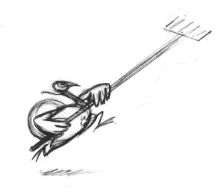
Fly High with NHG’s

TURKEY VAULT
CLINIC

NOVEMBER 8 & 9, 2025

Time to get ready for Indoor Season! New Heights Gym is hosting its annual pole vaulting clinic. This clinic will be a great opportunity to jump indoors and to introduce correct pole carry, plant techniques, run mechanics and gymnastics to the vaulters. The goal is to match correct run, pole, and grip height to each vaulter’s ability. We have a large selection of poles on hand; but vaulter may bring own poles. Only ¼” pyramid spikes allowed.

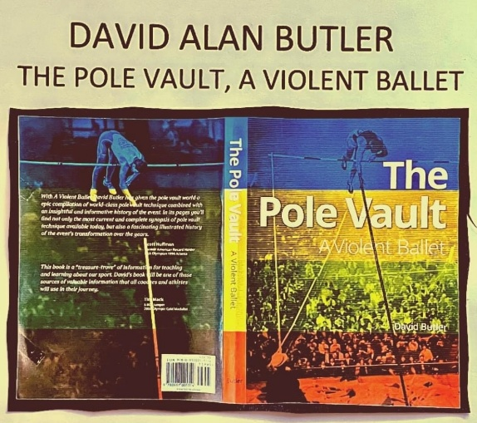
This year’s clinic will bring back collegiate coach David Butler from Rice University. Coach Butler has over 40 years of experience as a pole vaulter, educator, and coach. He is a member of the USA National Pole Vault Executive Staff, the USA National Pole Vault Summit Staff, and USA National Pole Vault Hall of Fame Committee. Coach Butler is also the established author of “The Pole Vault – A Violent Ballet”. His accolades are far too great to list in one page.

The clinic will be broken up into two sessions:
Day 1 – Saturday, November 8
9:00 AM – Noon Alignment Jumping & Pole Carry Technique (short steps)
Noon – 1:30 PM Lunch break (bring lunch/drinks or bring money to buy lunch)
1:30 PM – 5:00 PM Vault and Run Mechanics, then Review
Day 2 – Sunday, November 9
10:00 AM – 1:00 PM Pole Vault, Review, Discussion, & Questions

The cost for the clinic is $200/person. All vaulters must have current USATF membership. It is suggested to bring about $40 for food, drinks, and snacks.

For more information, contact Shane LeLeux at 337-359-7314.

NHG TURKEY VAULT

REGISTRATION FORM

Name: _____________________________Gender: M / F Age: _____Phone: _________________

Address: ____________________________________________ Email: _____________________________
USATF /AAU #: _______________ Club Affiliation: _____________________ PR: _______

Division (circle one): Youth (13 – 14) Girl / Boy Intermediate (15 – 16) Girl / Boy

Young (17 – 18) Women / Men Open Adult (19 – 29) Women / Men

Masters (30 +) Women / Men Open Youth (12 & Under) Girl / Boy

RELEASE OF CLAIMS

It is my understanding that there are certain risks involved with participating in the pole vault. In recognition of the possible dangers connected with pole vaulting and any physical activity, I hereby knowingly and voluntarily waive and right of cause of action of any kind whatsoever arising as a result of such activity, from which any liability may or could accrue to Shane LeLeux, Bridget LeLeux, New Heights Gym, and its officers, agents, employees, or instructors.

If under eighteen (18) years of age, parent or legal guardian must sign.

________________________________________________________________________________________
Print Name of Athlete Signature of Athlete Date

________________________________________________________________________________________
Print Name of Parent/ Guardian Signature of Parent/ Guardian Date
- This event is sanctioned by USATF
- All participants must have a current USATF membership.
- USATF membership must be obtained before the competition begins except where the event operator has a laptop available with an internet connect.

Mail Completed Entry Form, USATF membership number, and Release with Entry Fee to:

New Heights Gym
P.O. Box 9838
New Iberia, LA 70562

